**Upgradation from 11g to 19c (dbua)**

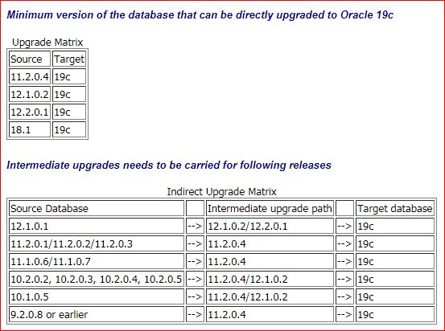

**Automatic Setup**

* **If you plan to use the "oracle-database-preinstall-19c" package to perform all your prerequisite setup, issue the following command.**

**#** yum install -y oracle-database-preinstall-19c

**Create the required directories**

mkdir -p /home/oracle/app/oracle/product/19c/dbhome_1

chown -R oracle:oinstall /home

chmod -R 775 /home

**PRE-UPGRADE TASKS**

1. **Take the backup of the database.**
2. **Create restore point.**
3. **Check the component status.(desc dba_registey)**

SQL>**Select comp_id,version,status from dba_registry;**

1. **Check the invalid objects.**

SQL>**select count(*) from dba_objects where status='INVALID';**

* **if any invalid compoments and objects run ultrp.sql script(@?/rdbms/admin/utlpr.sql)**

1. **Install 19c software**.( /SSD/oracle/app/oracle/product/19c/dbhome_1)
2. **select version from v$timezone_file;**
3. **Empty RECYCLEBIN**

SQL> PURGE DBA_RECYCLEBIN ;

**Run preupgrade script**

* **/SSD/oracle/app/oracle/product/11.2.0.4/dbhome_2/jdk/bin/java -jar /SSD/oracle/app/oracle/product/19c/dbhome_1/rdbms/admin/preupgrade.jar FILE DIR /SSD/19c**
* **This script will create 3 files in the /SSD/19c location.**

1. **Preupgrade.log**
2. **Preupgrade_fixups.sql**
3. **Postupgrade_fixups.sql**

* **Preupgrade.log file will contain some recommendations like memory increase,tablespace resize,gather stats.(REQUIRED ACTIONS)**
* Once the recommended changes are done.Re-run the preupgrade script one more time and check if any other recommendations.

# **Connect to sql and run**

1. EXECUTE gather stats on DICTIONARY_STATS and FIXED_OBJECTS_STATS before upgrade also.

* SQL> Execute DBMC_STATS.GATHER_DICTIONARY_STATS;

* SQL> Execute DBMC_STATS.GATHER_ FIXED_OBJECTS_STATS;

1. Now run **Preupgrade_fixups.sql** On 11g database.

SQL> @/SSD/19c/preupgrade_fixups.sql

1. min_recovery_area_size    NO          Manual fixup required.
2. parameter_min_val         NO          Manual fixup recommended.
3. em_present                NO          Manual fixup recommended.
4. amd_exists                NO          Manual fixup recommended.
5. apex_manual_upgrade       NO          Manual fixup recommended.
6. trgowner_no_admndbtrg     YES         None.
7. pre_fixed_objects         YES         None.
8. tablespaces_info          NO          Informational only.Further action is optional.
9. exf_rul_exists            NO          Informational only.Further action is optional.
10. rman_recovery_version     NO          Informational only.Further action is optional.
11. The fixup scripts have been run and resolved what they can. However,
12. there are still issues originally identified by the preupgrade that
13. have not been remedied and are still present in the database.
14. Depending on the severity of the specific issue, and the nature of
15. the issue itself, that could mean that your database is not ready
16. for upgrade.  To resolve the outstanding issues, start by reviewing
17. the preupgrade_fixups.sql and searching it for the name of
18. the failed CHECK NAME or Preupgrade Action Number listed above.
19. There you will find the original corresponding diagnostic message
20. from the preupgrade which explains in more detail what still needsto be done.
21. PL/SQL procedure successfully completed.

**Login** to VNC and invoke **/SSD/app/oracle/product/19.0.0/dbhome_1/bin** dbua

* ./dbua

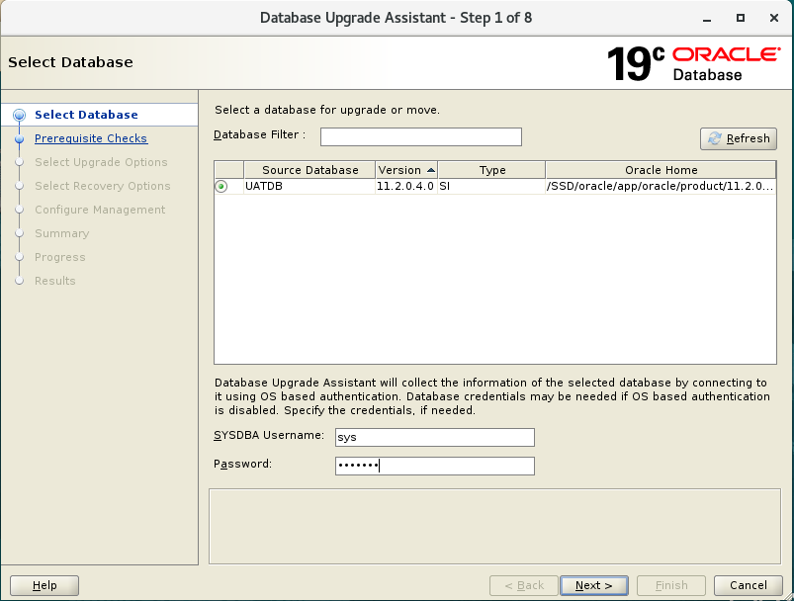

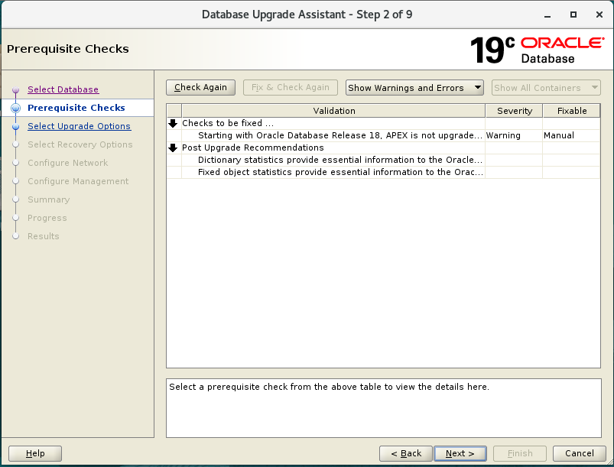

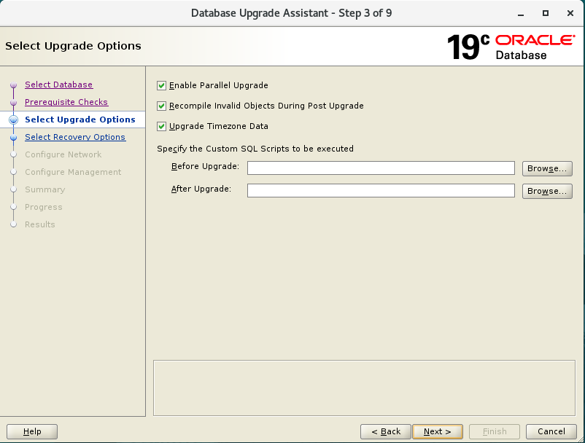

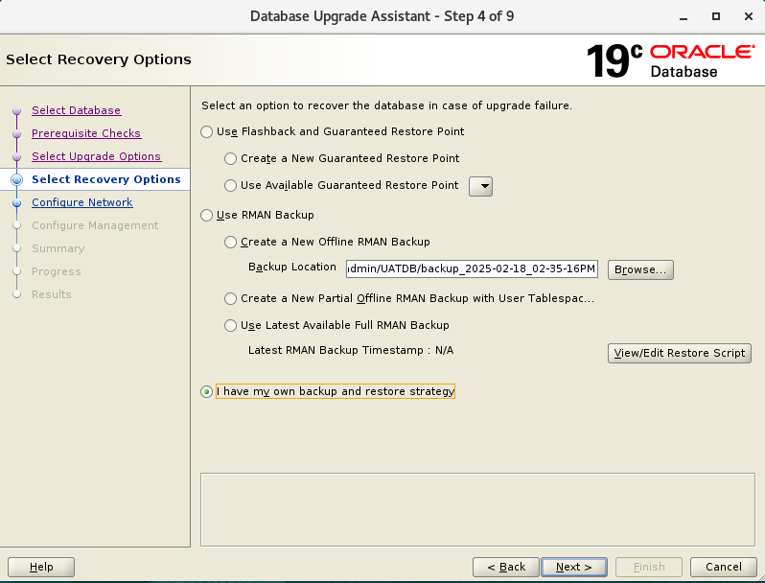

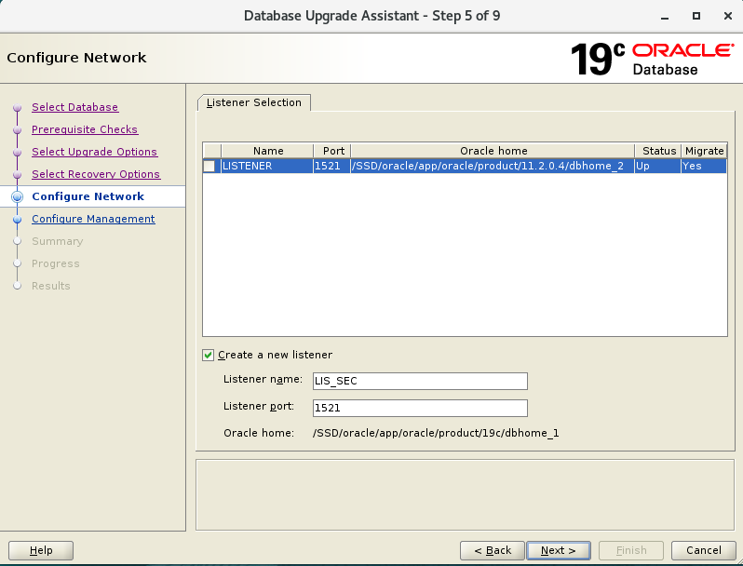

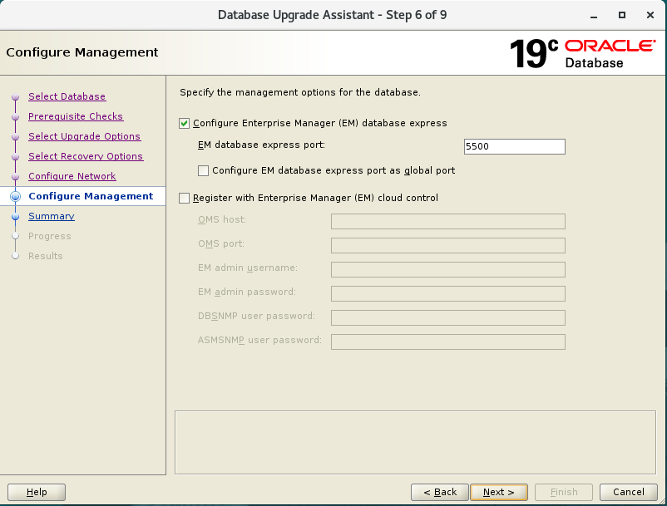

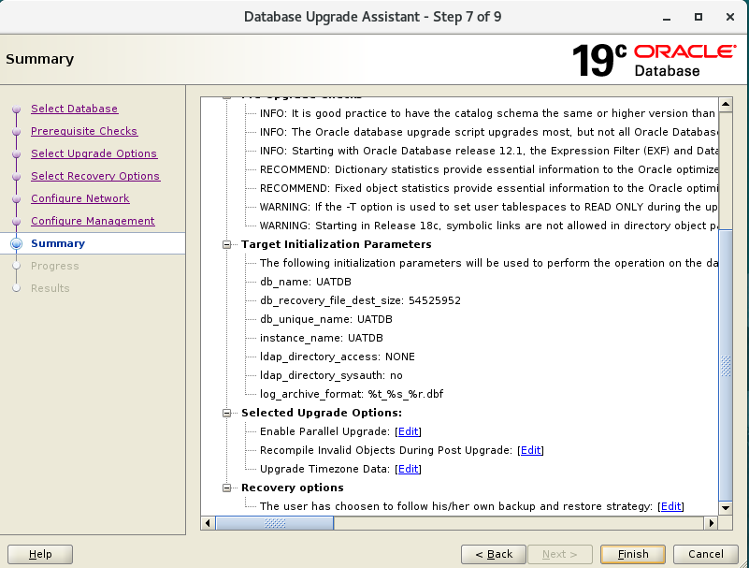

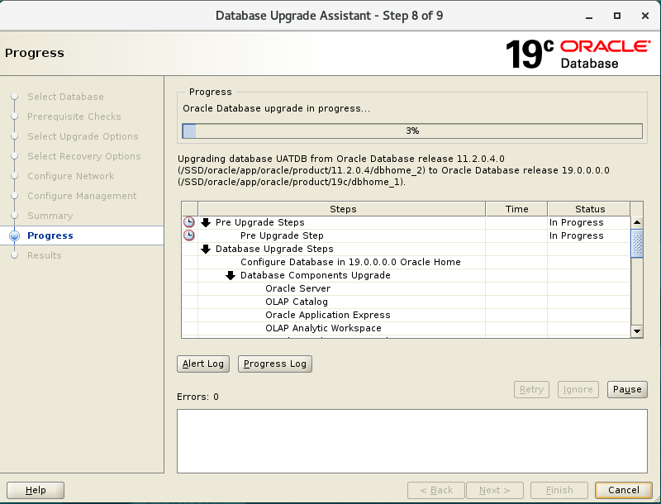

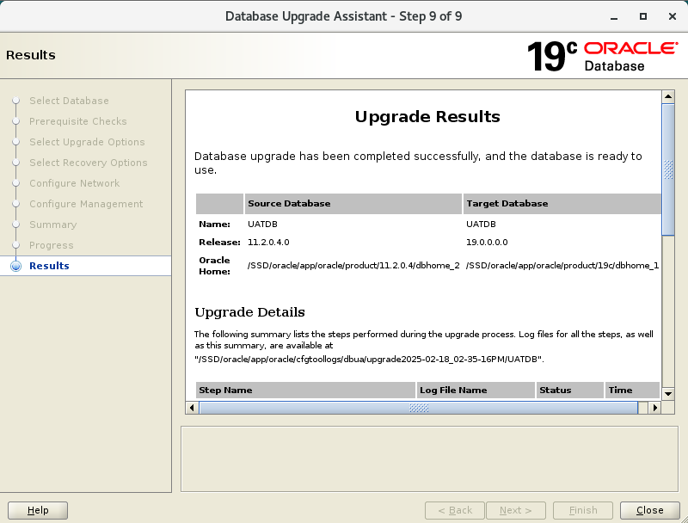

Close the GUI and set(. oraenv)

* Connect o sqlplus / as sysdba
* Check the version,components

SQL> select banner from v$version;

SQL>select comp_id,version,status from dba_registry;

Run postupgrade_fixups.sql

SQL>@/SSD/19c/postupgrade_fixups.sql

* Check for the invalid objects.(@?/rdbms/admin/utlrp.sql)

Change compatible parameter.

SQL>show parameter compatible;

* Alter system set compatible=’19.0.0.0’ scope=spfile;
* Shut immediate;
* Startup;